**Environment:** Analysis was performed on TEST environment.

General info:

|  |  |  |  |  |  |
| --- | --- | --- | --- | --- | --- |
|  | **Host** | **Type** | **IP** | **Hosted Applications** | **Ports** |
| STAGING | EPUAKYIW1686T1 | VM | 10.17.175.63 | EPUAKYIW1686T1.kyiv.epam.com | 8080, 4444 |

System resources (TEST env):

|  |  |  |
| --- | --- | --- |
| **CPU, GHz** | **Memory, Gb** | **Disk size, Gb** |
| 2 | 8.192 | 100 |

**Test scenario**

There is a combined scenario which is to include the scripts:

• Task 4 (admin)

• Task 5 (editor)

• Task 6 (anonymous)

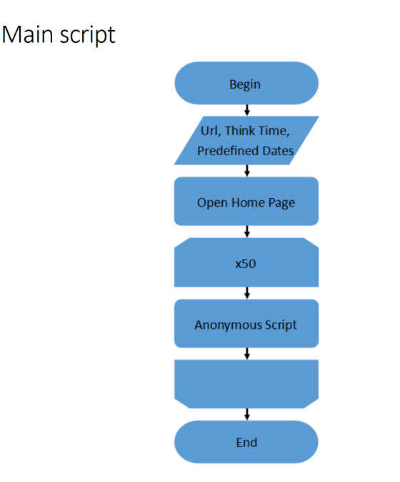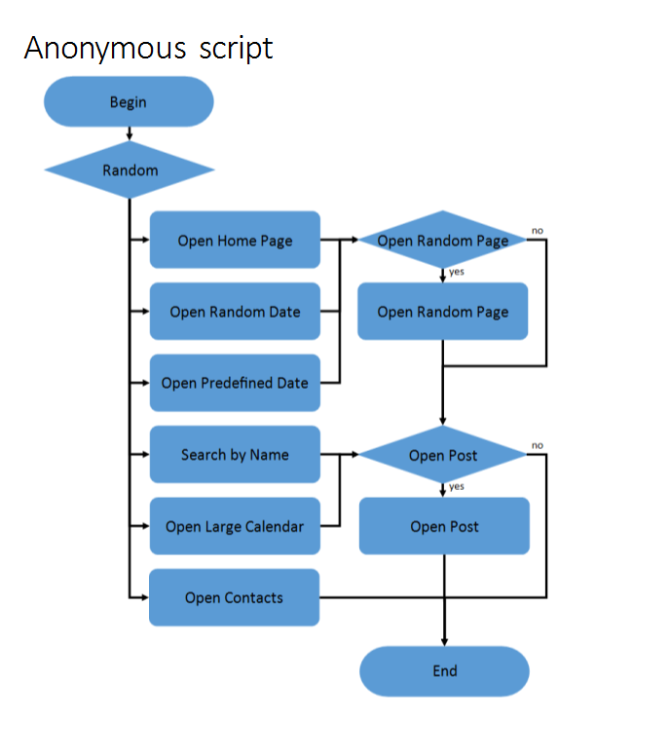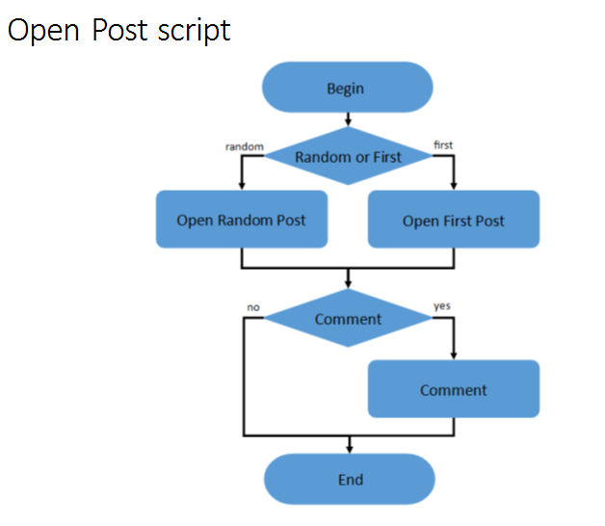

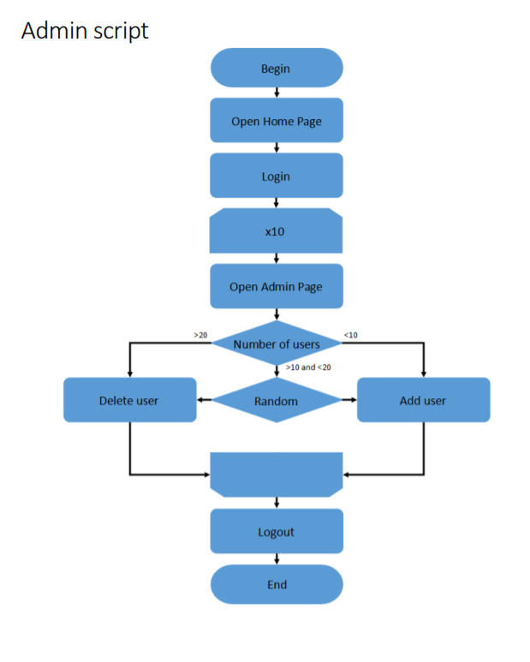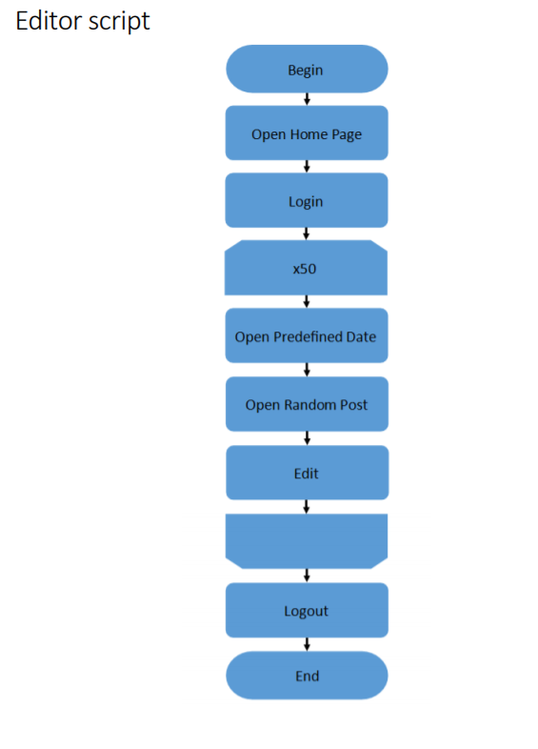

**Test conditions**

|  |  |
| --- | --- |
| **Transaction** | **Condition for anonymous script** |
| open home page | 15% |
| open random date | 10% |
| open predefined date | 30% |
| search by name | 30% |
| open large calendar | 10% |
| open contacts | 5% |
| open random page | 50% |
| open post | 80% |
| open random post | 65% |
| open first post | 35% |
| add comment | 20% |

**Test Setup**

|  |  |
| --- | --- |
|  | Condition |
| number of virtual users | Up to 40 – Anonymous  2 – Admins  2 – Editors |
| ramp-up period(sec) | 400 – Anonymous  30 – Admin  30 ­­­– Editor |
| duration(sec) | 600 |
| think time (sec) | 3-5 |

**Data Setup**

|  |  |  |
| --- | --- | --- |
| Configuration | Posts amount | Posts data |
| **1** | 2000 | Text only |
| **2** | 2000 | Mixed |

**Test Results**

|  |  |  |  |  |
| --- | --- | --- | --- | --- |
| Configuration | Avg throughput, ops | Avg response time,  ms | Avg CPU % | Avg Processor time % for ISS |
| **1** | 6.85 | 107 | 35 | 39 |
| **2** | 6.88 | 131 | 34 | 44 |

**Test Summary**

1 From gathered results, we can see only slight degradation on avg response time 107ms against 131ms.

2 Degradation could be found on Change Post transaction, Comment transaction, Open Admin Page transaction and slight(from 100ms to 300ms) degradation with the rest part of requests.

3 There is degradation on server in Processor time %.

Processor time % (avg)

39% - (1 Data configuration)

44% - (2 Data configuration)

**Results: graphs and tables(for more details open dashboard HTMLReport > index)**

1. Metrics Overview

1 Data configuration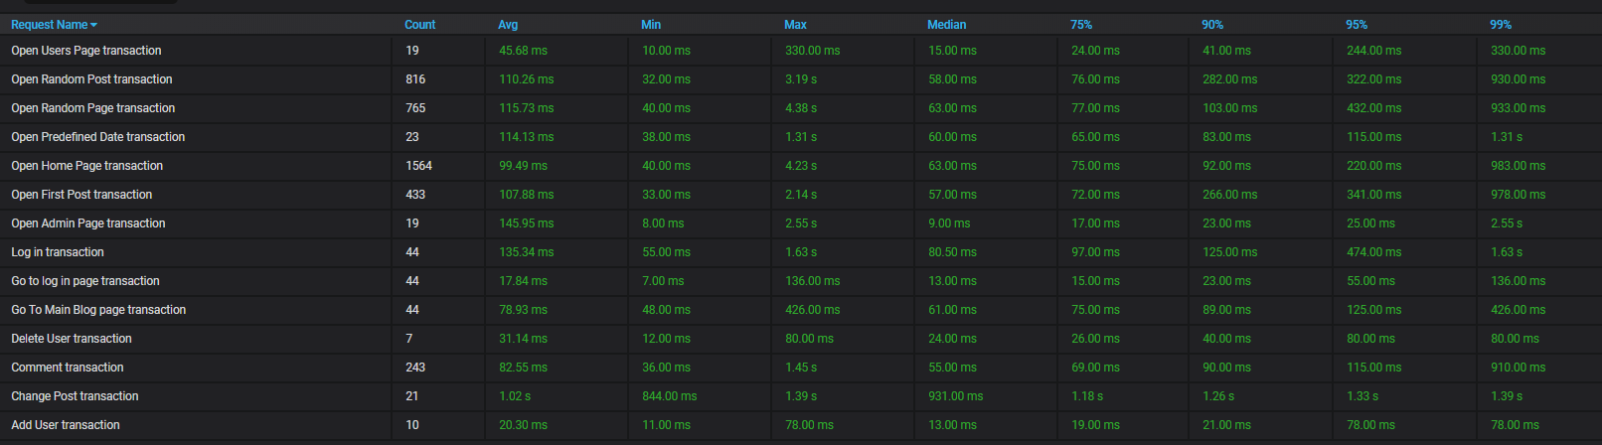

2 Data configuration

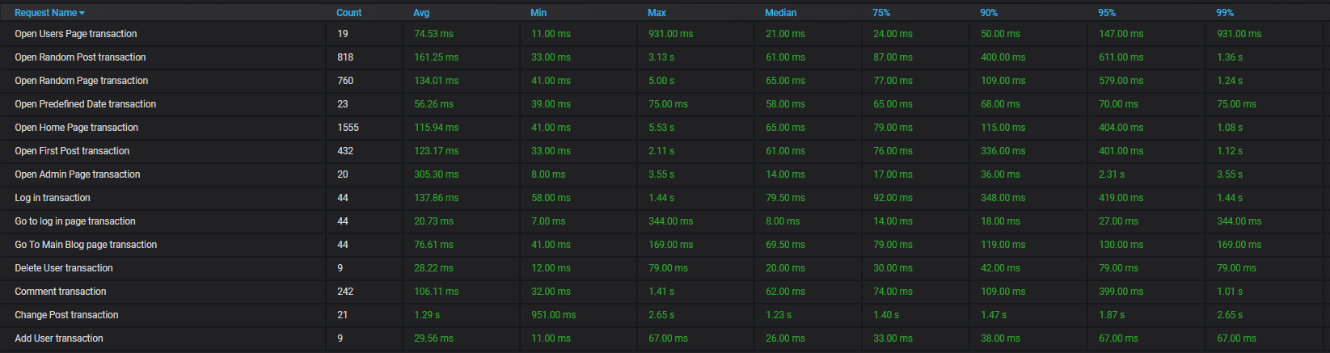

2 Processor time %

1 Data configuration

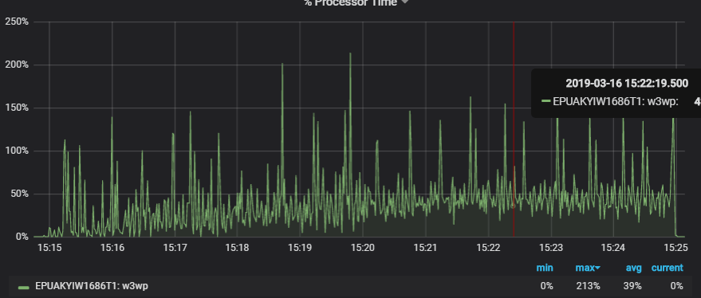

2 Data configuration

